

1. Overview

ur proposal to you from Deloitte is a private, internally authenticated monitoring system for the 9

items of heavy machinery in operation across the 4 global Daikibo Industrials locations. This software

will relay and summarize machine statuses live to you in the form of a simple and accessible

dashboard using the telemetry data you can already supply. Overall, we believe this proposal will suit

the current needs of your business and will optimize your productivity and product output by quickly

and effectively identifying which machines and locations which most critically require your attention.

ur proposal to you from Deloitte is a private, internally authenticated monitoring system for the 9

items of heavy machinery in operation across the 4 global Daikibo Industrials locations. This software

will relay and summarize machine statuses live to you in the form of a simple and accessible

dashboard using the telemetry data you can already supply. Overall, we believe this proposal will suit

the current needs of your business and will optimize your productivity and product output by quickly

and effectively identifying which machines and locations which most critically require your attention.

ur proposal to you from Deloitte is a private, internally authenticated monitoring system for the 9

items of heavy machinery in operation across the 4 global Daikibo Industrials locations. This software

will relay and summarize machine statuses live to you in the form of a simple and accessible

dashboard using the telemetry data you can already supply. Overall, we believe this proposal will suit

the current needs of your business and will optimize your productivity and product output by quickly

and effectively identifying which machines and locations which most critically require your attention.

ur proposal to you from Deloitte is a private, internally authenticated monitoring system for the 9

items of heavy machinery in operation across the 4 global Daikibo Industrials locations. This software

will relay and summarize machine statuses live to you in the form of a simple and accessible

dashboard using the telemetry data you can already supply. Overall, we believe this proposal will suit

the current needs of your business and will optimize your productivity and product output by quickly

and effectively identifying which machines and locations which most critically require your attention.

Our proposal to you from Deloitte is a private, internally authenticated monitoring system for the 9items of heavy machinery in operation across the 4 global Daikibo Industrials locations. This software will relay and summarize machine statuses live to you in the form of a simple and accessibledashboard using the telemetry data you can already supply. Overall, we believe this proposal will suitthe current needs of your business and will optimize your productivity and product output by quickland effectively identifying which machines and locations which most critically require your attention.

ur proposal to you from Deloitte is a private, internally authenticated monitoring system for the 9

items of heavy machinery in operation across the 4 global Daikibo Industrials locations. This software

will relay and summarize machine statuses live to you in the form of a simple and accessible

dashboard using the telemetry data you can already supply. Overall, we believe this proposal will suit

the current needs of your business and will optimize your productivity and product output by quickly

and effectively identifying which machines and locations which most critically require your attention.

2. Scope

The dashboard’s clean drop-down list format is able to fit onto one screen. This minimizes clutter andallows you to efficiently see machine health on a factory-wide or specific machine level and where anyissues may lie, without having to dig for the information you seek. The inclusion of machine healthhistory provides you with a machine’s history of uptime and downtime, which can be utilized as ameasure of its reliability and condition (if it has had numerous issues within an unreasonable amountof time). Furthermore, by knowing how much time a machine takes to be repaired, your time resourcesin future can be optimized



3. Estimate

The development targets entail thecoding and creation of the webpage in-cluding all necessary features and theuser interface. The testing targets in-volve the process of running the soft-ware, either with the client’s Intranetsystem or with our (Deloitte’s) own toensure it works without any issues byidentifying errors in programming orwith compatibility between the softwareand its host. Finally, the integration tar-gets are included to ensure that afterthis webpage has been developed andproperly tested on several occasions, itcan be fully and properly installed intoyour Intranet, ready for use. In total, weestimate that the complete develop-ment, testing and integration of this so-lution will take about 178 – 200 workinghours

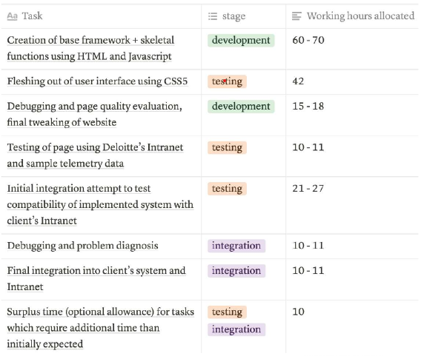

4. Timeline

1. Software Development Proposal
2. 4. Timeline
3. 1. [1st of September, 2021] Design starts
4. 2. [1st – 10th of September, 2021] Creation of base framework + skeletal functions using HTML and JavaScript
5. 3. [11th – 18th of September, 2021] Fleshing out of user interface (UI) using CSS5
6. 4. [19th – 22nd of September, 2021] Debugging and page quality evaluation, final tweaking of website code
7. 5. [22nd – 25th of September, 2021] Testing of page using Deloitte’s Intranet and sample telemetry data
8. 6. [25th – 30th of September, 2021] Initial integration attempt to test compatibility of implemented system with client Intranet
9. 7. [1st – 3rd of October, 2021] Debugging and problem diagnosis
10. 8. [4th – 7th of October, 2021] Final integration into client’s system and Intranet
11. ♣[Surplus time (optional allowance for tasks which require additional time than initially
12. expected
13. Software Development Proposal
14. 4. Timeline
15. 1. [1st of September, 2021] Design starts
16. 2. [1st – 10th of September, 2021] Creation of base framework + skeletal functions using HTML and JavaScript
17. 3. [11th – 18th of September, 2021] Fleshing out of user interface (UI) using CSS5
18. 4. [19th – 22nd of September, 2021] Debugging and page quality evaluation, final tweaking of website code
19. 5. [22nd – 25th of September, 2021] Testing of page using Deloitte’s Intranet and sample telemetry data
20. 6. [25th – 30th of September, 2021] Initial integration attempt to test compatibility of implemented system with client Intranet
21. 7. [1st – 3rd of October, 2021] Debugging and problem diagnosis
22. 8. [4th – 7th of October, 2021] Final integration into client’s system and Intranet
23. ♣[Surplus time (optional allowance for tasks which require additional time than initially
24. expected

Timeline1. [1st of September, 2021] Design starts

2. [1st – 10th of September, 2021] Creation of base framework + skeletal functions using HTML and JavaScript

3. [11th – 18th of September, 2021] Fleshing out of user interface (UI) using CSS5

4. [19th – 22nd of September, 2021] Debugging and page quality evaluation, final tweaking of website code

5. [22nd – 25th of September, 2021] Testing of page using Deloitte’s Intranet and sample telemetry data

6. [25th – 30th of September, 2021] Initial integration attempt to test compatibility of implemented system with client Intranet

7. [1st – 3rd of October, 2021] Debugging and problem diagnosis

8. [4th – 7th of October, 2021] Final integration into client’s system and Intranet▪[Surplus time (optional allowance for tasks which require additional time than initiallyexpected

5. Support

Software Development Proposal

5. Support

For urgent issues you face on a daily-weekly basis, you can call us at Deloitte if you run into basic software issues

and require a technician to examine the problem, and we will have the issue fixed within an estimated 1 – 3 business

days. Quarterly, Deloitte will email a selected head member of Daikibo Industries from each location and request any

feedback you may have about the system, or any improvements you would like to see in the software. The

continuous chain of feedback which you provide will help ensure our solution’s longevity as a part of your businesses

and factories by adapting to any changes you make or encounter. Yearly, we propose a board meeting with a

selected head member from every Daikibo Industries factory, and/or a member who uses our software to have a

more formal and thorough face-to-face discussion about the solutions we have in place for you. This yearly meeting

will allow us to have a consistent point of contact to touch bases about problems and issues with your software or

other important areas you think Deloitte is able to assist you with. We hope these support methods are adequate to

maintain and upkeep the product which we will create for you

Software Development Proposal5. SupportFor urgent issues you face on a daily-weekly basis, you can call us at Deloitte if you run into basic software issues and require a technician to examine the problem, and we will have the issue fixed within an estimated 1 – 3 business days. Quarterly, Deloitte will email a selected head member of Daikibo Industries from each location and request any feedback you may have about the system, or any improvements you would like to see in the software. The continuous chain of feedback which you provide will help ensure our solution’s longevity as a part of your businessesand factories by adapting to any changes you make or encounter. Yearly, we propose a board meeting with a selected head member from every Daikibo Industries factory, and/or a member who uses our software to have a more formal and thorough face-to-face discussion about the solutions we have in place for you. This yearly meeting will allow us to have a consistent point of contact to touch bases about problems and issues with your software or other important areas you think Deloitte is able to assist you with. We hope these support methods are adequate to maintain and upkeep the product which we will create for you